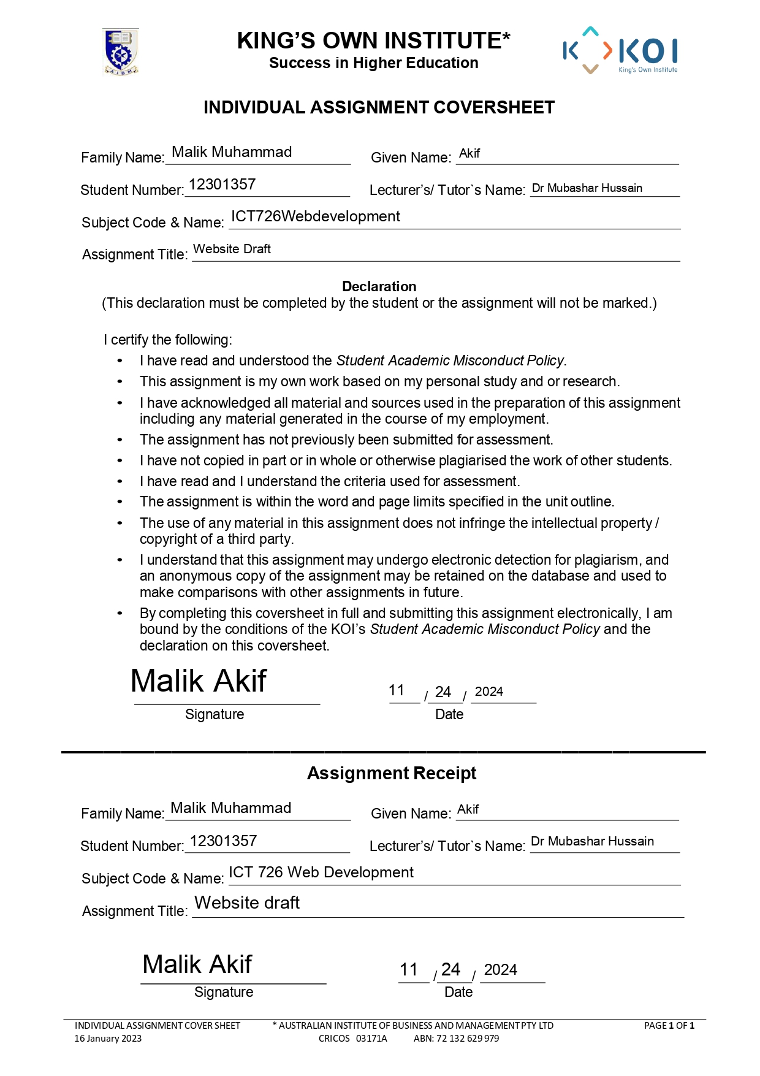

**Wireframes**

1. **Home Page (index.html)**
   * **Wireframe Description:**
     + **Header:** Logo on the left, navigation menu on the right with links to key sections (Featured Artists, Exhibitions, Virtual Tour, Booking, and About Us).
     + **Hero Section:** Full-width background image with an overlay title (Art in Motion) and a brief description.
     + **Featured Artists Section:** Grid of cards showcasing artists, with clickable expansion functionality for details.
     + **Exhibitions Section:** Grid layout for upcoming exhibitions, each card includes a Book Now button.
     + **Virtual Tour Section:** A call-to-action button to explore the gallery virtually.
     + **Footer:** Links and copyright text.

**Visual Representation:**

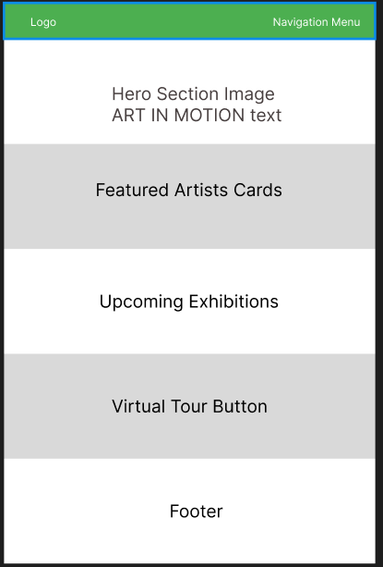

**About Page (about.html)**

* **Wireframe Description:**
  + **Header:** Similar to the home page.
  + **Mission and Story Section:** Two sections with headings and paragraphs.
  + **Team Section:** Cards with team member photos, names, and roles in a responsive grid layout.
  + **Footer:** Standard footer with copyright.

**Visual Representation**:

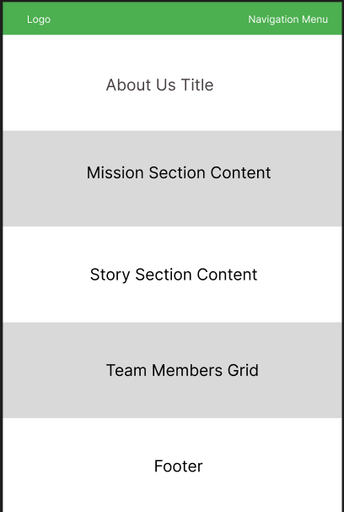

**Booking Page (booking.html)**

* **Wireframe Description:**
  + **Header:** Title of the page (Exhibition Booking).
  + **Booking Form:** Dropdown for exhibitions, date picker (enabled dynamically), text fields for name, email, and phone number, and a submit button.
  + **Footer:** Standard footer with copyright.

**Visual Representation:**

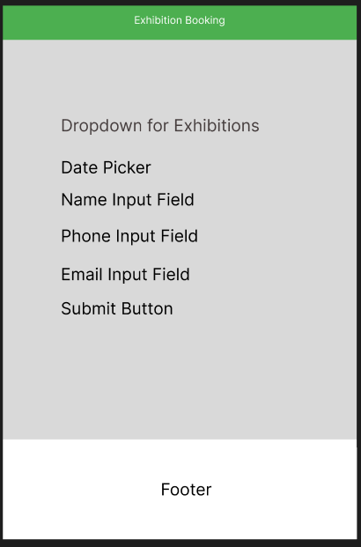

**Virtual Tour Page (virtual-tour.html)**

* **Wireframe Description:**
  + **Header:** Title of the page (Creative Canvas Virtual Tour).
  + **Interactive 360° Scene:** A-frame-based interactive virtual tour displayed in full-page width and height.
  + No footer or other sections

**Visual Representation:**

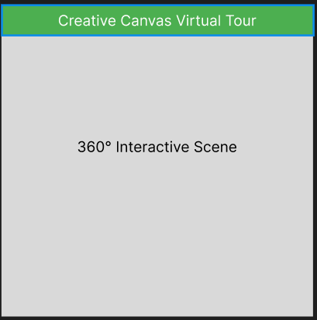

**Features and Description**

1. **Home Page (index.html)**

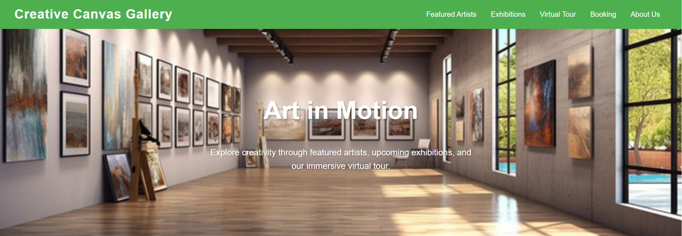

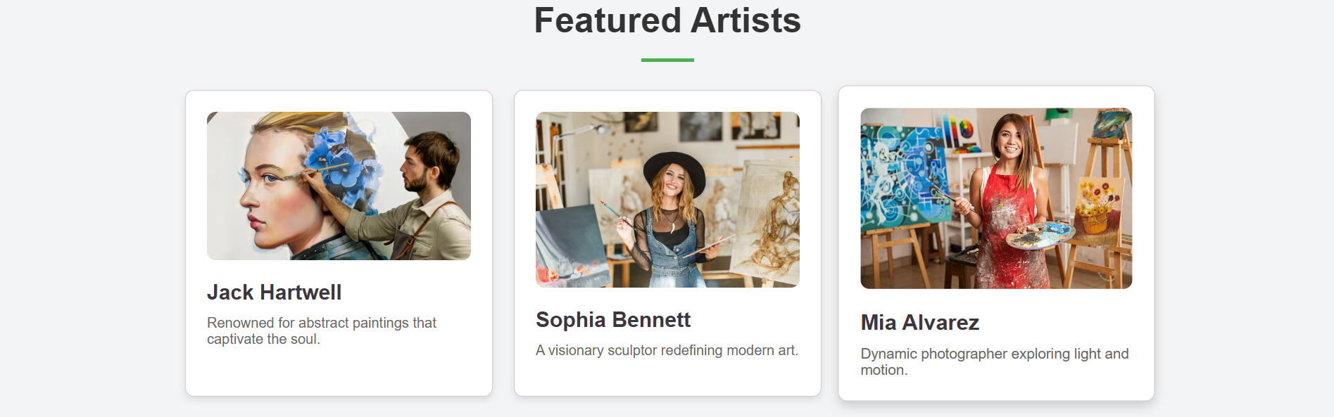

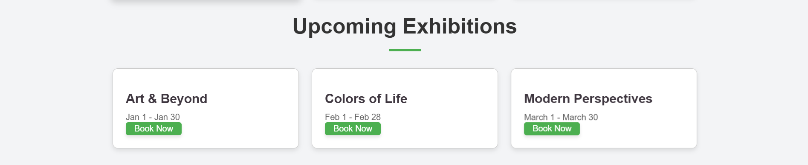

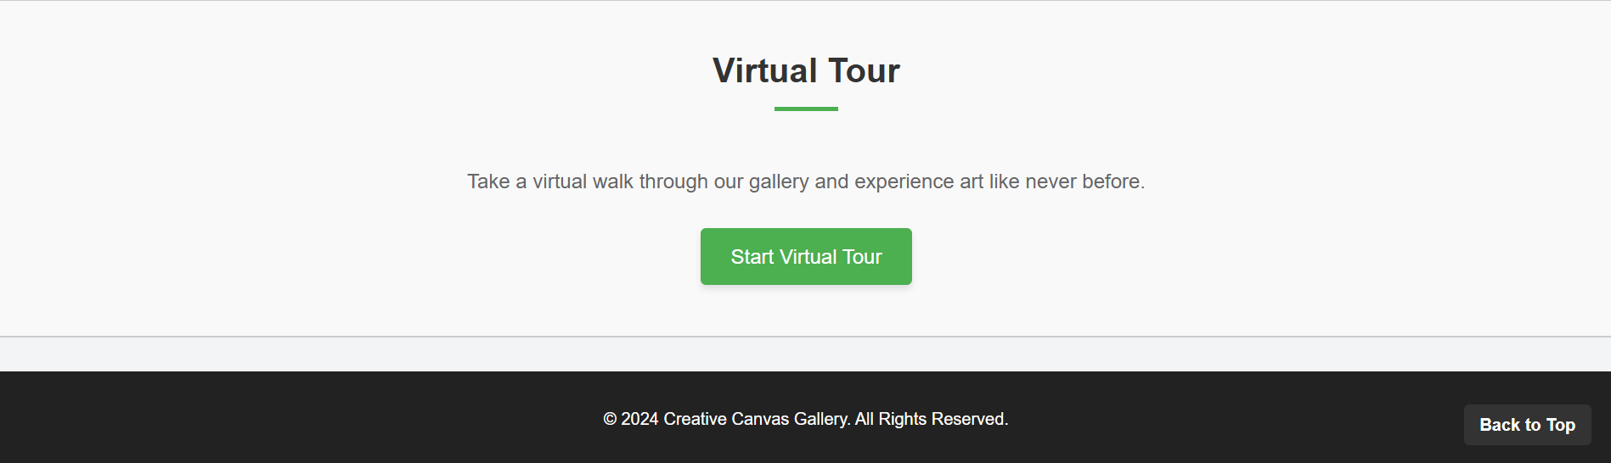

* **Features:**
  + **Navigation Bar:** Fully functional navigation links allowing users to scroll to specific sections or visit other pages like About or Booking.
  + **Hero Section:** Engaging full-width background image with overlay text that highlights the gallery’s essence, acting as the visual focal point.
  + **Featured Artists Section:**
    - Card layout for showcasing prominent artists with names, profile images, and brief descriptions.
    - Expandable content feature to reveal additional details about each artist without navigating to another page.
  + **Upcoming Exhibitions Section:**
    - Grid layout for event information with dates and themes.
    - A Book Now button on each card redirects to the booking page.
  + **Virtual Tour Section:**
    - Call-to-action button leading to an immersive 360° virtual tour experience.
  + **Footer:** Provides copyright information and additional links for quick navigation.
* **Layout:**
  + The layout prioritizes visual appeal with clearly separated sections using padding and margins.
  + A grid-based structure ensures responsiveness for artists and exhibitions, scaling well on different screen sizes.
  + Bold typography and shadow effects are used to make content stand out, while hover effects provide interactivity.

1. **About Page (about.html)**

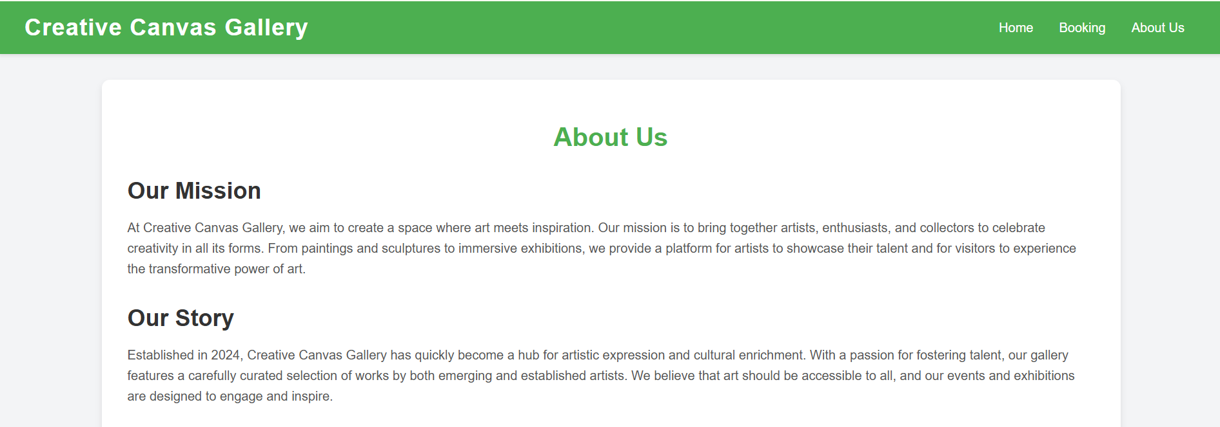

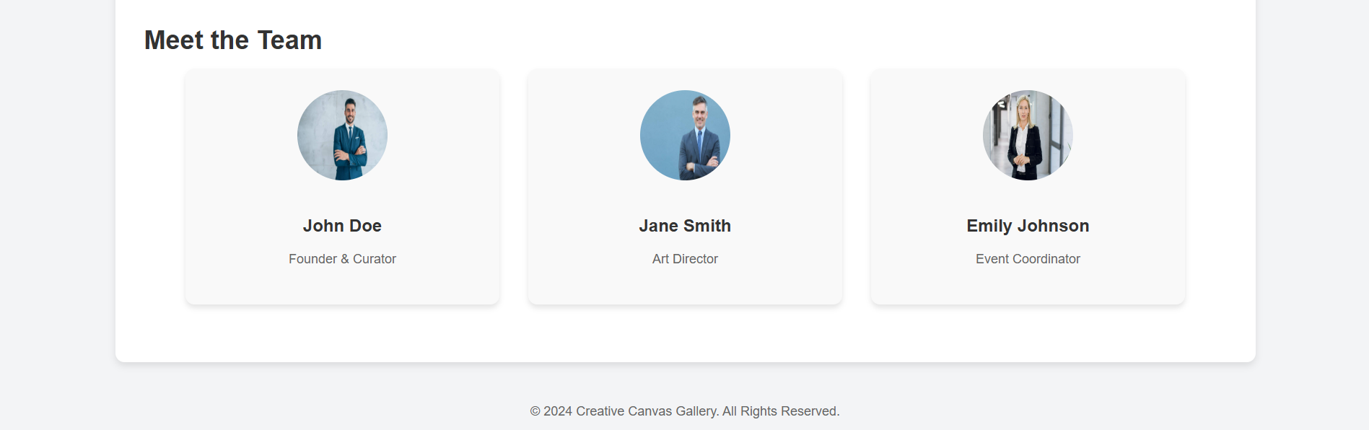

* **Features:**
  + **Our Mission:** Highlights the gallery’s purpose with a focus on community engagement and artistic celebration.
  + **Our Story:** A narrative-driven section presenting the gallery’s journey, including milestones and accomplishments.
  + **Meet the Team:**
    - Cards for each team member with profile pictures, names, and roles.
  + **Footer:** Includes copyright information and ensures consistent branding.
* **Layout:**
  + Organized into three distinct sections (Mission, Story, and Team) for easy readability.
  + Team section uses a flexible grid layout to ensure responsive design, displaying team members side-by-side on larger screens and stacked on smaller screens.
  + Visual hierarchy is maintained through headings, subheadings, and consistent fonts.

1. **Booking Page (booking.html)**

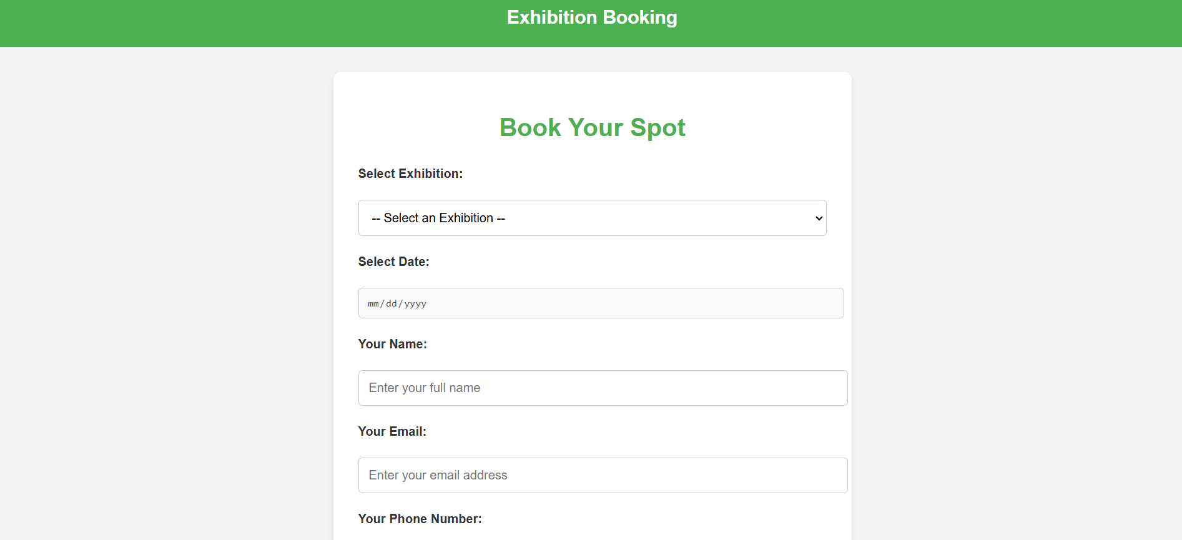



* **Features:**
  + **Dynamic Exhibition Selection:**
    - Dropdown menu for users to select their preferred exhibition.
    - Date picker is dynamically enabled with predefined date ranges for each exhibition.
  + **User Information Form:**
    - Fields for name, email, and phone number.
    - Form validation to ensure correct inputs before submission.
  + **Submit Button:** Highlights interactivity and responsiveness, designed with hover effects.
  + **JavaScript Logic:** Updates available dates in the picker based on the selected exhibition.
* **Layout:**
  + Center-aligned form with clearly labeled fields for user convenience.
  + Intuitive navigation with spaced-out elements to avoid overwhelming the user.
  + Minimalist design, focusing solely on the booking functionality without distractions.

1. **Virtual Tour Page (virtual-tour.html)**

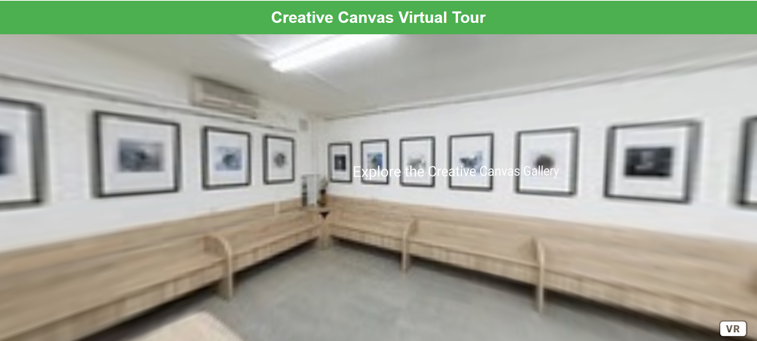

* **Features:**
  + **360° Interactive View:**
    - Powered by A-Frame, providing users an immersive experience of the gallery space.
    - Rotatable view with mouse or touch gestures.
    - A prominent text overlay to guide the user during the experience.
  + **Simple Interface:** No additional elements to distract from the interactive experience.
  + **Responsive Design:** Adapts seamlessly to various devices, including desktops, tablets, and mobiles.
* **Layout:**
  + Full-screen immersive layout with no clutter.
  + Virtual tour element occupies the entire viewport below the header, maximizing the user experience.
  + Clean and minimalist header ensures branding consistency.

**AI Assistance Explanation**

1. **AI Tools Used:**
   * AI-assisted coding for expandable artist cards, dynamic date picker logic in JavaScript, and A-Frame integration for the virtual tour.
   * Styling: Suggestions for CSS enhancements like shadows, hover effects, and responsive layouts.
2. **Planned Customizations:**
   * Refine layout spacing and typography

**References:**

Link to Figma: <https://www.figma.com/design/BZ9DjjaT6hCLYQtDRFTWR2/Untitled?node-id=0-1&t=32qFVj80iY18zZBt-1>

Link to drive: <https://drive.google.com/drive/folders/12GUomuxHK4HaKTdJrNIcidkp9qMT-m6S?usp=sharing>